**Multiple spawning events promote increased larval dispersal of a predatory fish in a western boundary current**

Hayden T. Schilling1,2*, Jason E. Everett1,3, James A. Smith1, John Stewart4, Julian M. Hughes4, Moninya Roughan5,Colette Kerry5, Iain M. Suthers1,2

1. Centre for Marine Science & Innovation, UNSW Australia, Sydney, NSW 2052, Australia
2. Sydney Institute of Marine Science, Building 19, Chowder Bay Road, Mosman, NSW 2088, Australia
3. University of Queensland
4. New South Wales Department of Primary Industries, Sydney Institute of Marine Science, Chowder Bay Road, Mosman, NSW 2088, Australia
5. Coastal and Regional Oceanography Laboratory, School of Mathematics and Statistics, UNSW Australia, Sydney, NSW, 2052, Australia

* Corresponding author

Running title: larval dispersal in a western boundary current

**Target journal**: Fisheries Oceanography

Word count: ~6500 (excluding figures, tables and references)

**Notes to co-authors:**

* There is some stuff in the methods which is sort of introduction-like but I have left it in the methods as I think it explains why we did some stuff, in particular the degree-days stuff.
* I can’t do error bars on Figure 7 (CPUE stuff), there is no error estimate, a single CPUE value per year and a single number of settled larvae predicted to settle each year (relative between years, not absolute values, similar to rest of the paper).

**Abstract**

Transport of fish larvae by ocean currents to juvenile habitats is an important mechanism for many marine species, particularly those in boundary current systems. The timing and location of spawning in relation to ocean currents greatly influences the dispersal and settlement location of larvae and is valuable information for species management. A previously unrecognised summer spawning event and more southern latitudinal extent for the spring spawning event was recently reported for the southwest Pacific population of *Pomatomus saltatrix.* Although fishing restrictions are in place to protect the northern traditionally recognised spring spawning event, the importance of the summer spawning event is uncertain. Here we investigate larval dispersal pathways in the East Australian Current through particle tracking simulations to identify the contributions of the different spawning events to potential settlement along the east Australian coast. By modelling the dispersal pathways of larvae released in northern and mid-latitude regions over spring and summer we show that the mid-latitude summer spawning event contributes over 50 % of the larvae reaching southern latitudes. This is due to a 1 – 2 day shorter pelagic larval duration, resulting in reduced larval mortality, and the seasonal strengthening of the East Australian Current driving particles 50 km further south. Spawning over broad temporal and spatial scales by *P. saltatrix* may have developed as a mechanism to ensure maximum dispersal of larvae.These findings demonstrate that the final settlement location of larvae that are transported by ocean currents can vary considerably depending on the timing and location of spawning with multiple spawning events having variable importance along a species’ distribution.

Keywords: particle tracking, connectivity, larval transport, pelagic larval duration, tailor, bluefish, *Pomatomus saltatrix*

**Introduction**

For many broadcast spawning species, ocean currents transport larvae away from spawning sites, with some fraction of the larvae arriving at and settling in juvenile habitats potentially hundreds of kilometres away from the original spawning site (Cowen et al. 2006; Cetina-Heredia et al. 2019). Both seasonal and fine scale temporal variation in ocean currents can result is vastly different larval distributions, contributing to highly variable recruitment (Houde 1989b; Siegel et al. 2008). Many species spawn at specific times of the year and in specific locations, potentially utilising favourable oceanography to maximise larval survival (Cowen and Sponaugle 2009; Davies et al. 2014). Understanding the ocean transport of larvae therefore has great potential to inform species management.



With advances in computing power and higher resolution ocean models, hydrodynamic models parameterised with species specific information are increasingly being used to understand and manage connectivity in the marine environment (Gallego et al. 2007; Hinrichsen et al. 2011). By tracking particles (larvae) within a Lagrangian modelling framework, and quantifying their dispersal patterns relative to suitable juvenile habitats, it is possible to identify important areas for larval production (Everett et al. 2017; Munroe et al. 2018). High resolution hydrodynamic models provide a mechanism to examine the physical factors which shape observed distributions of larvae and settled juveniles. More than 500 hydrodynamic models have been successfully applied in many systems (Nolasco et al. 2018), including the Southern Ocean (Fraser et al. 2018), western boundary currents (Coleman et al. 2011; Cetina-Heredia et al. 2015; Cetina-Heredia et al. 2019) and seas such as the Mediterranean Sea (Andrello et al. 2013). These models have provided insight into transport and connectivity for a variety of organisms such as kelp (Coleman et al. 2011; Fraser et al. 2018), invertebrates (Everett et al. 2017; Munroe et al. 2018; Cetina-Heredia et al. 2019) and fish (Paris et al. 2005; Santos et al. 2018) at both small and large scales (Roughan et al. 2011; Hellweger et al. 2014; Schunter et al. 2019) as well as insights into the impacts of projected climate driven changes to boundary current circulation and hence dispersal (Coleman et al. 2013; Cetina-Heredia et al. 2014).

Western boundary currents (WBCs) are swift, narrow oceanic currents found in all major oceanic gyres (Hu et al. 2015). These currents typically flow from the equator towards the poles and transport large amounts of warm water into more temperate regions, simultaneously transporting larvae and other planktonic organisms into more temperature regions (Roughan et al. 2011; Coleman et al. 2013). The East Australian Current (EAC) is a WBC which flows poleward along eastern Australia. It has relatively weak mean flow compared to other subtropical gyres but is characterised by high eddy variability. The EAC flows strongly along the coast (EAC Jet) until 31 – 33° S where it separates from the coast, turning eastward (Cetina-Heredia et al. 2014). Following the separation, there is a complex field of eddies which flow both east (EAC eastern extension) and south (EAC southern extension; Oke et al. 2019). The EAC and associated extensions are a major driver of connectivity for marine organisms in eastern Australia. It has previously been shown that larval dispersal in this region is heavily influenced by mesoscale oceanography (Everett et al. 2017; Cetina-Heredia et al. 2019) and that particles originating inside the EAC have greater coastal connectivity than those released offshore (Roughan et al. 2011). As a control of connectivity, the EAC is important for fisheries via the transport of larvae to appropriate juvenile habitat (Condie et al. 2011; Everett et al. 2017).



Many fish species are known to have complex spawning behaviour, and the timing and location of spawning, in particular, can have a large influence on settlement location and success due to seasonal variation in oceanography (McEvoy and McEvoy 1992; Taylor and Able 2006). *Pomatomus saltatrix* for example, is a globally important recreational and commercial fish species (Juanes et al. 1996) which has recently had a second, previously unknown spawning event identified in the East Australian Current system (Schilling et al. 2019). *P. saltatrix* is a globally distributed and important fisheries species with recognised spawning migrations in boundary current systems (East Australian Current, Gulf Stream, Agulhas Current and Brazil Current), andis thus an ideal candidate to investigate larval dispersal within WBCs (Juanes et al. 1996). In the Gulf Stream, previous research used oceanography, wind and satellite derived temperature to investigate larval transport processes of *P. saltatrix* and proposed that the number of juveniles recruiting to estuaries is closely linked to warm-core ring streamer activity and that the timing of estuarine entrance is determined by the timing of the breakdown of the surface shelf/slope temperature front (Hare and Cowen 1996). In the southwest Pacific Ocean, *P. saltatrix* (locally known as tailor) undertake annual migrations along the East Australian Current (Brodie et al. 2018). In winter, *P saltatrix* migrates north, up to 26° S (Fraser Island) where in spring the main spawning event occurs (Brodie et al. 2018). This spawning event at Fraser Island is well documented (Pollock 1984; Zeller et al. 1996), resulting in a seasonal closure (August – September) of fishing to protect the species (Leigh et al. 2017). However, it was recently shown that the latitudinal range of the spring spawning event extends south to 30° S and a previously unrecognised spawning event occurs between 28° S and 30° S during summer (Schilling et al. 2019). Given the current management focuses only one a subset of the spawning activity for this species, it is important to quantify the relative importance of this temporally and spatially extended spawning to the dispersal of *P. saltatrix*, above that achieved by the traditional spawning event at Fraser Island. This has broader implications for understanding how other species with multiple spawning events use variation in western boundary currents to maximise larval dispersal.

The overall goal of this study was to understand how multiple spawning events can influence larval dispersal in a western boundary current by investigating the dispersal of *P. saltatrix* larvae off eastern Australia, utilising a particle tracking model and the recently recognised extension to this population’s spawning. Specifically, this study aimed to 1. compare potential settlement of larvae at different latitudes along eastern Australia from the different spawning events, and 2. investigate if observed locations of juvenile *P. saltatrix* can be explained by the recently recognised spawning events.

**Methods**

*Hydrodynamic model details*

To investigate oceanographic larval dispersal from the identified spawning periods, particle tracking experiments were run using an offline Lagrangian particle tracking model, PARCELS “Probably A Really Computationally Efficient Lagrangian Simulator” (Lange and van Sebille 2017; Delandmeter and van Sebille 2019). These simulations used the velocity fields from a Regional Oceanographic Modelling System (ROMS 3.4) configuration of the East Australian Current System (Kerry and Roughan In Revision). The model domain extends from Fraser Island in the north (25.12° S) to south of the Australian mainland (41.55° S) and approximately 1000 km offshore (162.22° E), encompassing the EAC system from where it is most coherent to where it separates from the coast and forms an energetic eddy field in the Tasman Sea (Figure 1). The model is eddy resolving, has a 2.5 – 6 km cross-shore resolution and a 5 km alongshore resolution, with 30 vertical s-levels. The vertical stretching scheme used ensures a constant-depth surface layer to better resolve the ocean surface currents (Souza et al. 2015). This model provides higher horizontal resolution on the continental shelf (2.5 km cross-shelf and 5 km along-shelf) than any other available models of the EAC system. This is important as it allows sub-mesoscale and cross-shelf processes, which may influence transport of particles along the continental shelf, to be better captured.

The model is a free-running simulation covering a 22-year period (1994 – 2016) and has a configuration fully detailed in Kerry and Roughan (In Revision). It is a temporal extension of the 2-year simulation described in Kerry et al. (2016). Model output is saved as daily averages. Although the simulation is free running, as it is nested within the most recent BlueLink Reanalysis (BRAN3p5; Oke et al. 2013) its boundaries are constrained by observations. This is important because the northernmost extent of *P. saltatrix* spawning occurs at 26° S (Fraser Island; near the northern extent of the model). At this location, the EAC has a strong coherent flow along the coastline (Sloyan et al. 2016; Kerry and Roughan In Revision), and with the boundary of the model constrained by observations we are confident that the poleward flowing EAC is being accurately represented at the northern boundary of the model domain.

The model of the EAC was assessedagainst Sea Surface Height (SSH) and geostrophic velocity data from the Archiving, Validation and Interpretation of Satellite Oceanography Data (AVISO) product (CNES 2015), SRS Satellite Level 3 1-day composite Sea Surface Temperature (SST) data obtained though Australia’s Integrated Marine Observing System (IMOS, https:portal.aodn.org.au) and Argo profiling floats (Roemmich et al. 2009). Comparisons of volume transported by the EAC were also made with estimates from full depth moorings (Sloyan et al. 2016) and a combination of XBT, Argo and altimetry data (Zilberman et al. 2018). The simulated hydrodynamics were found to be consistent with the observations. The ROMS simulation provides a very good representation of the currents in the EAC separation region, and accurately represents the spatial patterns of mesoscale SSH variability driven by the dynamic mesoscale eddy field, the EAC separation and the seasonal SST cycle over the 22 year simulation period (Kerry et al. 2016; Kerry and Roughan In Revision).

*Particle characteristics*

The Lagrangian particle simulations were conducted using PARCELS v2.0 which is an open source framework for simulating Lagrangian particle trajectories, designed to efficiently process large amounts of data. Lagrangian simulations were run using only surface velocities as *P. saltatrix* larvae are found almost exclusively at the surface in this region (Miskiewicz et al. 1996). The paths of each particle were interpolated using 5 min steps based upon the daily velocity fields from the ROMS model output. Each particle included a small Brownian motion walk function of 100 units which added natural variation to the movement of each particle and ensured no two particles followed the exact same path (van Sebille et al. 2018; Scutt Phillips et al. 2019).



The growth rates and pelagic larval durations (PLDs) of many larvae are temperature dependant (Houde 1989a; Green and Fisher 2004), so the duration of tracking for each particle (pelagic larval duration) was temperature dependant and estimated using degree-days (DD; thermal constant; Neuheimer and Taggart 2007; O'Connor et al. 2007). With this approach, each particle is assumed to settle when the cumulative sum of daily temperatures experienced by that particle reaches the thermal constant (Everett et al. 2017; Figures S1 & S2). Larval growth in *P. saltatrix* is both temperature- and size-dependant with larvae growing faster in both warmer waters and at larger sizes, resulting in exponential growth in the larval size range (Hare and Cowen 1995; Hare and Cowen 1997). Published growth and temperature data for *P. saltatrix* were combined to estimate a thermal constant for various stages of development (Deuel et al. 1966; Hare and Cowen 1995; Juanes et al. 1996). Larvae (2.1 mm) hatch from eggs at 39 DD, growth from the yolk sack occurs at a rate of 0.039 °C d-1 until 2.9mm (59.3 DD), at which point the growth rate growth changes to 0.003 mm mm-1 °C-1 d-1 which results in an exponential shaped curve with our specified settlement occurring at 500 DD (10.7 mm; Figure S3). This growth rate closely matches observed growth rates in larval *P. saltatrix* (Hare and Cowen 1995; Juanes et al. 1996). For a constant water temp of 22 °C, this means larvae will settle after 23 days which matches the observed transition from larvae to juvenile in this species (Hare and Cowen 1994; Figure S3). We used a settlement time of 500 DD (10.7 mm) as it is just before the transition from larvae to juvenile whereby swimming would become vastly more important than passive drift from ocean currents (Hare and Cowen 1994; Hare and Cowen 1996; Neira et al. 1998). The temperatures experienced by each particle along its path was recorded from the ROMS model once per day and this was used to calculate the DD for each particle (Figure S2).

Natural mortality was incorporated into this model by releasing many particles and applying a daily mortality rate to each cohort of particles. Because natural mortality is a daily constant for each cohort and the same number or particles are released each day per location, the number of particles dying each day is constant between cohorts until particles reach the settlement time and the number of particles in each cohort may begin to vary. To save computing time and reduce the number of starting particles we needed to model, we only applied mortality from day 16 onwards (prior to any particle reaching 500 DD and settlement occurring), when mortality starts to vary between cohorts. As the actual larval mortality rate of *P. saltatrix* in this region is unknown we applied an instantaneous daily mortality rate (*M*) of 0.25, which is equivalent to a 22.12 % actual daily mortality rate. This mortality value was selected as it is the approximate mean *M* for the temperatures observed along the EAC system (Houde 1989a). While this value may vary from the actual *M*, applying a daily mortality rate in conjunction with the growth specified in degree-days allowed us to model the effect of increased cumulative mortality on larval cohorts that have a longer PLD, spending longer in the water column (and are therefore more vulnerable to predation) before settlement. Larvae which were not on the continental shelf (between the coast and the 200m isobath) at settlement (500 DD) were also considered mortalities in terms of analysis (dispersal mortality; Everett et al. 2017). To better represent percentages of settlement, the effective number of particles released was determined by calculating the number of particles which would have been released in each spawning event to be equal to the actual number of particles on day 16 (when we started to apply natural mortality) if mortality had been applied from day 1.

*Forward simulation of observed spawning events*

Particle release locations and months were specified to simulate the observed *P. saltatrix* spawning periods (Schilling et al. 2019). Three spawning events were modelled in this study, a northern spring spawning event (26 – 27.5° S release locations), a mid-latitude spring (28.5 – 30° S) spawning event and a mid-latitude summer (28.5 – 30° S) spawning event (Figure 1; Table 1). The spring spawning events spanned August – December inclusive and the summer spawning event combined February and March releases. By incorporating the ‘new’ spawning information into particle tracking models (Schilling et al. 2019), we are exploring the importance of these ‘new’ spawning events. Within these release locations particles were released every 0.5° latitude at the surface over the 100 m isobath to encompass all locations *P. saltatrix* in spawning condition were observed in Schilling et al. (2019). As no data is available on relative spawning biomass at different locations or times, we assumed a constant daily spawning rate at all locations. A cohort of 1000 particles were released from each location every day (during the spawning months) for 22 years (the duration of the ROMS model).



*Backward simulations from locations of observed juvenile P. saltatrix*

Backward Lagrangian particle tracking simulations were run using the same particle characteristics, except mortality was not incorporated as we know the settlement locations of the particles and are only interested in the potential spawning locations that could have resulted in transport to these locations, rather than any measure of density. Locations were determined by juvenile tailor observations (Table 1; Leigh et al. 2017; Schilling et al. 2018; Schilling 2019). Because the poleward flowing East Australian Current dominates the circulation upstream of 31o S, we did not simulate any backwards tracking releases north of 31° S as the majority of the particles were estimated to leave the northern boundary of the ROMS model (which corresponds to the most northern spawning for this population). As no mortality was modelled for the backwards simulations, a smaller cohort of 100 particles were released per location (Table 1; Figure 1) every 7 days for 22-years on the 100 m isobath. These particles were subset to only include those which were predicted to have spawned during the spawning months (August – December, February or March).

*Catch-per-unit-effort*

We explored whether the modelled transport and settlement of *P. saltatrix* was correlated with observed recruitment, using catch-per-unit-effort (CPUE) used as an indicator of recruitment. *P. saltatrix* catch is most variable at the southern end of its distribution (> 37° S), therefore we used a CPUE index from the southern latitudes (Victorian Fisheries Authority 2017) as it is most likely to show a clear signal in larval dispersal-driven recruitment variation. The CPUE data from the Gippsland Lakes seine net fishery (Victorian Fisheries Authority 2017) was provided as the mean for each year (1998 – 2018). Because *P. saltatrix* are most commonly caught at age 2 in the southwestern Pacific Ocean (Leigh et al. 2017; Schilling 2019), the relative predicted number of settled larvae south of -36° S during July - June (to cover the spawning season) were lagged by 2 years. We used CPUE data for years 1998 – 2018 to align with the particle tracking model (1996 – 2016).

*Data analysis*

Larval distributions from each particle tracking simulation were mapped to show the positions of all particles at 500 DD. Settlement from each spawning event was quantified by finding the percentage of all settled particles (final location inshore of the 200m isobath) in 1° latitude bins. Active movement is not included in the model, so estimates of survival are conservative with actual survival likely to be higher due to shoreward swimming (Hare and Cowen 1996). Therefore, the estimates presented are conservative lower estimates of relative settlement success, but likely fully represent potential dispersal and latitudinal transport distances. The same analysis was conducted with no mortality to assess the importance of including mortality in these models. For the CPUE analysis, the Pearson correlation coefficient was calculated to test for a statistically clear correlation between CPUE and the modelled larval settlement. Distance travelled was tested using a linear model with log­10 transformed distance the response and year and spawning event as fixed factors. Residual plots were inspected to check assumptions of the linear model and probability distributions were plotted for each spawning event to visualise distribution of distance travelled by particles in each spawning event.



**Results**

*Settlement time*

The temporal length of the PLD (500 DD) varied among the three spawning events (Figure 2). Using all particles which reached 500 DD, the mean PLDs for each spawning event were: northern spring 22.5 days, mid-latitude spring 23.2 days, and mid-latitude summer 20.8 days. For larvae that settled on the continental shelf the means varied slightly: northern spring 22.4 days, mid-latitude spring 23.5 days, and mid-latitude summer 21.1 days. This is important because a longer PLD implies increased exposure to mortality and potential further transport. In our simulations we applied a 22% daily mortality which means that, for every day extra prior to settlement, 22% of the surviving larvae die. In terms of the current results, this mean that the two day difference between spawning events is equivalent to 40 % of the particles alive at the earlier settlement day are dying prior to settlement day two days later. The longer PLD was also reflected in the distance transported with the mid-latitude spring spawning event clearly having a higher mean distance travelled (332 km) compared to both the northern spring (272 km) and mid-latitude summer spawning events (271 km; *P* < 0.001).

*Dispersal from spawning events*

The larval settlement locations simulated by the particle tracking model were almost exclusively southward except for 0.09 % of particles from the northern spring release which settled north of 26° S (Figure 3, Table 3). When investigating the distributions of larvae arriving on continental shelf within each spawning event, the northern spring spawning event had a peak in settlement around the release locations (27 – 28° S while the peaks in settlement for both mid-latitude spawning events were approximately 1 – 2 degrees south of the initial spawning locations (31 – 33° S). The mid-latitude spawning events also had a larger proportion of the successfully settling larvae arrive south of 30° S compared to the northern spring sample (Figure 4a). When these proportions were investigated as part of the total number of larvae arriving on the continental shelf, the northern spring spawning event suppled approximately 40 % of all larvae on the continental shelf, the majority of these north of 30° S (Figure 4b; Table 2). The mid-latitude spawning events supplied an overall lower proportion of the larvae but were increasingly important for larval supply with increasing latitude. The mid-latitude summer supplied double the larvae on the continental shelf compared to the mid-latitude spring spawning event (Figure 4b; Table 3).

In terms of dispersal mortality, a high proportion (55 – 84 %) of particles in each spawning period which survived to 500 DD were dispersed offshore, particularly south of the separation zone where the East Australian Current separates from the Australian mainland (Figure 3, Table 2). The mid-latitude spring spawning event had a low number of larvae reach 500 DD on the continental shelf (0.23 % of effective number of larvae released) compared to 0.75 % and 0.96 % respectively for the northern spring and mid-latitude summer spawning events (Table 2). This is reflected in the northern spring and mid-latitude summer spawning events having areas of high settlement density along the coast (near the spawning locations), while the mid-latitude spring spawning event had a wider dispersal of particles with a more even distribution of settlement latitudes (Figures 3 & 4). The mid-latitude summer spawning event extended the furthest south with moderate dispersal offshore (Figure 3).

When the contribution of each spawning event was investigated by settlement latitude, it showed that the three spawning events play a disproportionate role in delivering larvae to the southeast Australian coast (Figure 5). The northern spring spawning event (which covers the originally identified Fraser Island spawning event) supplied all larvae settling north of 28° S but the proportion of particles settling in each 1° latitudinal bin from the northern spring spawning decreased as latitude increased. The mid-latitude spring spawning event contributed a small proportion of particles settling between 28 and 30° S (< 15 %) but contributed between about 15 and 30 % for all latitudes south of 30°S. The mid-latitude summer spawning event contributed the largest proportions (30 – 60 %) of larvae that settled south of 29° S, with this spawning event contributing over 50 % of the larvae settling south of 37° S. When mortality was excluded from these simulations, the importance of the mid-latitude spring spawning event increased while the importance of the mid-latitude summer spawning period decreased (Figure S4), showing that mortality is an important factor contributing to larval settlement patterns.

*Backward tracking*

The backwards simulation of all larvae released at known juvenile locations revealed that the most likely spawning sites were dispersed along the coast to the north of the release sites (Figures S5, S6). Some particles were predicted to have come from offshore but in general the EAC appears to have restricted onshore-offshore movement (Figures S5, S6). After limiting the analysis to particles which were predicted to have originated on the continental shelf (as spawning only occurs along the coast), the connectivity matrix revealed that it was possible that larvae in the southern latitudes (< -36°) were potentially transported from up to 8 degrees further north (26° S; Figure 6). While there was higher probability for larvae to be transported short distances, it was still possible that larvae from all three spawning events could be contributing larvae to all locations where juvenile tailor are observed (Figure 6).

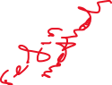

*Catch-per-unit-effort*



A statistically clear positive correlation (*r* = 0.463) was found between the predicted larval settlement south of 37° S and the CPUE data from the Gippsland lakes (*t*19= 2.777, *P* = 0.034; Figure 7). The lagged predicted larval settlement was strongly correlated between approximately 2004 and 2012. Despite this, there were several years where predicted larval settlement did not match the CPUE data including pre-2004 and after 2012. In the 1997-98 catch year (July – June) there were no larvae predicted to settle south of 37° S, driven by stronger offshore currents which resulted in no larvae being transported south of 36° S. There was large variation in interannual distribution patterns with some years’ larvae being transported much further south, while in other years there were large amounts of offshore transport (Figures S7 – S9).

**Discussion**

This study simulated larval dispersal from three recognised spawning events in a western boundary current, revealing the importance of the spawning events to settlement success can vary due to oceanographic processes. Understanding the temporal and spatial variability of spawning and settlement in this region is valuable for fisheries management, given it is dominated by a dynamic western boundary current region with strong seasonality, a dynamic eddy field, and circulation that is changing as a result of climate change. Our analysis shows that dispersal of larval *P. saltatrix* along the east coast of Australia is dependent on the multiple spawning events which contribute varying proportions of larvae along the coast, and that the recently confirmed summer spawning event is particularly important for settlement in the southern portion of this species distribution. This research demonstrates that dynamic ocean currents with seasonal variation can have a large influence on patterns of larval dispersal and settlement. By combining spawning information with particle tracking models, it is possible to better understand dispersal dynamics and connectivity which can lead to more effective fisheries management.

*Settlement times*

Differences in temperature can have substantial impacts on populations, with temperature directly influencing the pelagic larval duration (PLD; O'Connor et al. 2007; Schunter et al. 2019). In our study, using degree-days to model temperature dependant growth rates and PLDs resulted in different PLDs and therefore mortality among the three spawning events. For larvae settling in a suitable location (i.e. on the continental shelf), the mid-latitude summer spawning event settled on average a day earlier than the northern spring spawning event and 2 days earlier than the mid-latitude spring spawning event. This means that both the mid-latitude and northern spring spawning events were subject to increased mortality (up to 40 % of extra mortality of larvae compared to the shorter PLD) as they were vulnerable to predation in the pelagic environment for longer. This was reflected in the percentage survival and percentage settlement of the three spawning periods with the mid-latitude summer spawning event showing almost double the survival percentage of the mid-latitude spring spawning event (Table 2). Excluding mortality from these simulations, as some previous connectivity studies have done, results in the mid-latitude spring spawning event being over-represented in the final larval survival and settlement numbers (Figure S6). It is well recognised that increasing temperature reduces the PLD of most taxa and changing ocean temperatures have large implications for connectivity through changes in dispersal distance and survival (O'Connor et al. 2007; Treml et al. 2012). By including a temperature dependent PLD in particle tracking models, these models are better able to capture the important differences in survival and dispersal which may be driven by changes in water temperature. Degree-days (Everett et al. 2017; Samsing et al. 2017) and mortality associated with temperature thresholds (Cetina-Heredia et al. 2015) have been used successfully before in particle tracking models but it is still uncommon for models to incorporate the effects of temperature. Our findings confirm that when available, temperature dependant settlement (PLDs) should be included in particle tracking models to account for faster growth, earlier settlement, and therefore reduced mortality occurring in warmer waters (Houde 1989a; Neuheimer and Taggart 2007).

*Larval dispersal*

The forward simulations revealed that the northern spring spawning event is highly important for overall *P. saltatrix* population connectivity and recruitment. Assuming a constant rate of spawning (day-1), the northern spring spawning event has the largest number of larvae which settle on the continental shelf. However, both mid-latitude spawning events, which incorporate the recent information expanding the latitudinal and temporal spawning extent of *P. saltatrix* (Schilling et al. 2019), contribute more larvae to the southern part of the species range (south of 34° S). The mid-latitude summer spawning event contributed the highest proportion of settled particles south of 30° S, with the importance of this spawning event increasing with latitude. It is likely the two recently identified mid-latitude spawning events drive recruitment in southern Australian (south of 36° S), where commercial catch of *P. saltatrix* is small and often variable (Litherland et al. 2016; Victorian Fisheries Authority 2017). The fact that the simulated larval settlement matched some of the observed patterns in CPUE from the southern region suggests that oceanography is an important driver of *P. saltatrix* recruitment.

The northern spring spawning event had large numbers of larvae which settled north of the East Australian Current (EAC) separation zone (~32° S) before they could potentially be advected offshore. These northern particles were often driven by onshore currents which resulted in low velocities and short distances travelled due to interactions with the land. The greater offshore dispersal evident in both mid-latitude spawning events was driven by the EAC eastern extension where the EAC separates from the Australian coast (Oke et al. 2019). The results of this are seen in the concentrations of particles which ended up offshore, approximately 33 – 35° S. This could be further examined using the paths of individual particles which get advected offshore and entrained into eddies. These eddies are highly common along the east coast of Australia and particularly strong south of the EAC separation zone (Suthers et al. 2011; Everett et al. 2012). Climate change is driving change in the EAC region with the flow strengthening up to 35 % (Sun et al. 2012), and separation occurring further south (Cetina-Heredia et al. 2014), which will likely result in more larvae being dispersed offshore or potentially retained in eddies and returned to the shelf (Cetina-Heredia et al. 2019). This has large implications for the larval transport of many species, including *P. saltatrix*, which use this western boundary current for dispersal. Increased poleward dispersal of many species is already being observed along this coast, through increased poleward transport of tropical larvae and subsequent tropicalisation of temperate areas (Vergés et al. 2014; Miranda et al. 2019).

The backwards simulations from locations where juvenile *P. saltatrix* are found showed that the three identified spawning events have the potential to supply larvae to all locations. The most southern backwards release site (Gippsland Lakes, 38° S) had lowest likelihood of larvae being spawned in the identified spawning region (north of 30° S) and this is likely why the recruitment (and catch) of *P. saltatrix* in this southern region is highly variable (Leigh et al. 2017; Victorian Fisheries Authority 2017), with larvae not being consistently transported this far south. All other release locations for the backwards simulations showed very high likelihood that the larvae were spawned in the spawning region, corresponding to the regular observed annual recruitment. All backwards tracking models were showed a high likelihood of spawning along the coast (particularly north of 33° S), which highlights the fact that the EAC is the dominant coastal current with few currents delivering water from the more easterly ocean onto the continental shelf. This is consistent with previous research showing that western boundary currents can act as connectivity barriers between onshore and offshore areas (Roughan et al. 2011).

Although CPUE data is known to be a biased metric due to many factors such as changes in fisher behaviour, catchability, and management, and caution must be taken when linking CPUE to abundance (Rose and Kulka 1999; Maunder et al. 2006), our model exhibited similar patterns as observed in the CPUE data. The positive correlation between predicted larval settlement and the CPUE data from the Gippsland Lakes (38° S) provides evidence that our model is portraying accurate dispersal and settlement dynamics of this species. Using different oceanographic models with forecasting potential, it may be possible to forecast larval settlement of *P. saltatrix* and thus predict years of high and low potential catch for this fishery. The relationship between CPUE and modelled settlement was less clear towards the end of the simulated period, however, which may have been due to changes in the fishery, with fishing effort starting to increase in 2011 after a long decline (Victorian Fisheries Authority 2017). CPUE rose after 2016, while predicted settlement did not. If shoreward swimming was incorporated into this particle tracking model, this pattern may have been better captured (Putman and Mansfield 2015). Annual larval settlement distributions showed that the larvae did get dispersed south but ended up too far east, not on the continental shelf (Figures S4 – S6). The possible advantages of including active swimming in the models are discussed further in the model limitations section. In 1997, there was no predicted larval settlement south of 37° S, which seems highly unlikely as there was no visible decline in CPUE in 1999. As the CPUE is based upon total harvest and effort it incorporates variations from multiple year classes and therefore there will be some inherent differences between CPUE and predictions made from a single year of settlement. Because the catch of *P. saltatrix* contains multiple age classes, a more detailed analysis may be possible if the full age composition of the harvested fish was known. Another recent study which investigated lobster larvae settlement in the same region using a similar Lagrangian particle tracking methodology but with a different hydrological model (OFAM BRAN 3p5) found similar disjuncts (same years) when comparing predicted settlement to observed juvenile settlement (Cetina-Heredia et al. 2019). While neither the current study nor Cetina-Heredia et al. (2019) included particle behaviour such as swimming, the similarity (both good and bad) in ability to match settlement with predicted larval transport suggests that these ocean models can capture most of the oceanographic dynamics, however there continues to be a need to understand the impacts of active swimming and other smaller resolution oceanographic processes which may be contributing to actual larval settlement patterns (Fiksen et al. 2007; Putman and Mansfield 2015; Munroe et al. 2018).

*Model limitations*

This study aimed to model the potential latitudinal dispersal of tailor larvae in order to understand the importance of the recently described extensions in spawning latitude and timing (Schilling et al. 2019). The model used in this study was a free running ocean model which does not replicate oceanic conditions such as individual eddies but it does recreate broad seasonal and interannual patterns which allow us to investigate broad patterns of interannual and seasonal transport (Kerry and Roughan In Revision). Passive transport and temperature dependent growth and mortality are not the sole factors influencing the final distribution of fish larvae. It is known that active horizontal swimming can be important in determining the final destinations of all fish larvae (Fiksen et al. 2007; Putman and Mansfield 2015), although despite not modelling this component of transport, this model was able to capture the most of the interannual variation seen in the CPUE data from the southern portion of the distribution. For horizontal swimming to be incorporated into this particle tracking model, further research into the swimming abilities of larval *P. saltatrix* is required. It is likely that swimming would occur in a westward direction, towards the Australian coastline (and suitable juvenile habitat) but the magnitude of the swimming ability for larval *P. saltatrix* is currently unknown. The resultant larval distributions presented in this study suggest that *P. saltatrix* larvae are transported far offshore, including near Lord Howe Island (31.556° S, 159.082° E) where *P. saltatrix* are never observed as juveniles or adults (Van Horn et al. 2018). We believe that if active westward swimming was incorporated into this model, the resultant distributions would be more concentrated towards the Australian continent. This would also have helped improve some of the relationship between some of the lagged settlement estimations and the CPUE data in the years our model predicted southward transport but too far east of the continental shelf.

The hydrodynamic model used in our simulations is the highest resolution available for this region, particularly on the continental shelf but it still may not accurately capture some of the local hydrodynamics which may influence delivery of larvae to suitable habitat (Pineda et al. 2007; Kerry and Roughan In Revision). As an example, the winds incorporated into the ROMS model are course and therefore is unlikely to accurately capture the local ‘sea-breeze’ close to the shoreline. It is likely that incorporating high-resolution winds into the ROMS model would increase shoreward transport on the continental shelf but to a lesser degree than active swimming. Regardless of the limitations in longitudinal transport, we are confident that the latitudinal transport of *P. saltatrix* is well represented by this study.

*Conclusion*

This paper has shown that by spawning in different areas and times of the year, the final settlement locations of larvae can be substantially altered. This has important implications for all broadcast spawning species. If the timing or location of spawning is altered, it is possible that the resultant larval dispersal may vary greatly. Future work may further consider the changes that are occurring to ocean currents with climate change and how this may alter the larval transport of marine fish.

*Acknowledgements*

This work was funded by an Australian Research Council Linkage Project (LP150100923) and the NSW Recreational Fishing Trust. This research includes computations using the computational cluster Katana supported by Research Technology Services at UNSW Sydney. CK was partially funded by an Australian Research Council Grant LP160100162. Thanks to John Morrongiello and Francis Juanes who made useful comments on the thesis chapter which was the basis of this paper.

**Tables**

**Table 1** Site details for the particle tracking simulations. Forward tracking locations were based upon documented spawning events (Schilling et al. 2019). Backwards tracking locations were based on estuaries were juvenile *P. saltatrix* have been observed. All simulations were started on the 100 m isobath.

|  |  |  |
| --- | --- | --- |
| **Location** | **Latitude (°S)** | **Forward or Backwards Tracking** |
| Northern spawning event | 26, 26.5, 27, 27.5 | Forwards |
| Mid-latitude spawning event | 28.5, 29, 29.5, 30 | Forwards |
| Hastings River | 31.4 | Backwards |
| Wallis Lake | 32 | Backwards |
| Sydney Harbour | 33.8 | Backwards |
| Jervis Bay | 35.1 | Backwards |
| Wagonga Inlet | 36.2 | Backwards |
| Twofold Bay | 37 | Backwards |
| Gippsland Lakes | 38 | Backwards |

**Table 2**

Details of the forward tracking particles. As mortality was only modelled from the day prior to any settlement occurring (day 16), the effective number of released larvae is the number of released larvae which would be equivalent to applying mortality the whole time period and having the actual number of released larvae when mortality started to apply. The percentages were calculated using the effective number of larvae.

|  |  |  |  |  |  |  |
| --- | --- | --- | --- | --- | --- | --- |
| **Spawning event** | **Larvae released in model** | **Effective number of released larvae** | **Larvae surviving to 500 DD** | **Percent survival to 500 DD (%)** | **Larvae settled on shelf** | **Percent settlement on shelf (%)** |
| Northern spring | 3,366,000 | 111,466,577 | 1,876,658 | 1.684 | 839,376 | 0.753 |
| Mid-latitude spring | 3,366,000 | 111,466,577 | 1,538,584 | 1.380 | 253,234 | 0.227 |
| Mid-latitude summer | 1,298,000 | 42,983,844 | 1,172,266 | 2.727 | 412,769 | 0.960 |

**Table 3** Percentage of particles settling over the continental shelf in each degree of latitude from three spawning events. Spring spawning events include August – December and the summer spawning period includes February and March. Spawning locations are shown in Figure 1. The percentages were calculated on the effective number of released larvae (Table 2).

|  |  |  |  |
| --- | --- | --- | --- |
| **Settlement latitude (°S)** | **Northern spring (%)** | **Mid-latitude spring (%)** | **Mid-latitude summer (%)** |
| 25 – 26 | 0.003 | 0.000 | 0.000 |
| 26 – 27 | 0.071 | 0.000 | 0.000 |
| 27 – 28 | 0.245 | 0.000 | 0.002 |
| 28 – 29 | 0.144 | 0.014 | 0.061 |
| 29 – 30 | 0.077 | 0.029 | 0.192 |
| 30 – 31 | 0.065 | 0.042 | 0.226 |
| 31 – 32 | 0.052 | 0.040 | 0.180 |
| 32 – 33 | 0.044 | 0.035 | 0.118 |
| 33 – 34 | 0.031 | 0.032 | 0.080 |
| 34 – 35 | 0.013 | 0.017 | 0.048 |
| 35 – 36 | 0.005 | 0.009 | 0.024 |
| 36 – 37 | 0.002 | 0.005 | 0.014 |
| 37 – 38 | 0.001 | 0.004 | 0.015 |
| 38 – 39 | 0.000 | 0.000 | 0.001 |
| Successful Settlement | 0.753 | 0.227 | 0.960 |

**Figures**

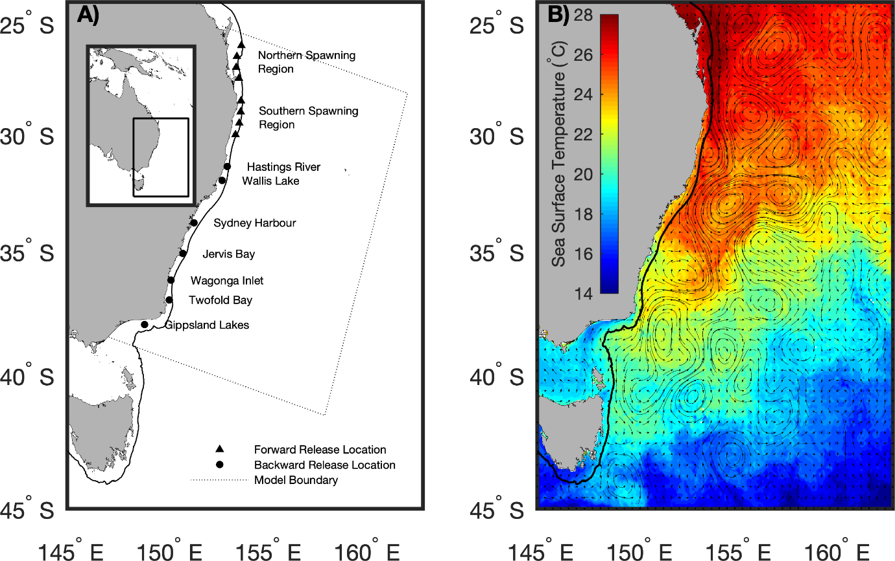

**Figure 1** a)Map of eastern Australia covering the latitudinal range of *Pomatomus saltatrix* (25 – 39° S). Symbols show the release location for the forwards (triangles) and backwards (circles) simulations. The dotted line represents the boundaries of the regional oceanographic model which provided the velocity estimates used in the simulations (Kerry et al. 2016) and the solid black line shows the 200m isobath, b) a visualisation of the ocean currents (black arrows) and sea surface temperature (colour) of the region.

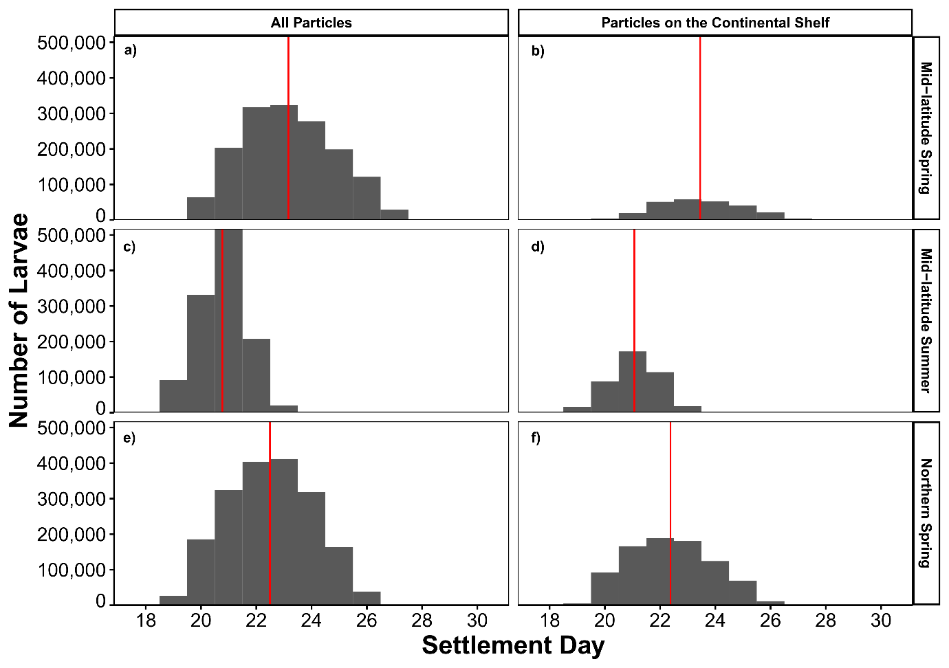

**Figure 2** Histograms showing the larval settlement times (pelagic larval duration) from the three spawning events, separated into all particles which reached 500 degree-days (DD) left, and particles which were over the continental shelf at 500 DD right. The red vertical line represents the mean settlement day for each group of particles.

**Figure 3** Relative density of larvae at settlement time (500 degree-days). The black circles with white outlines show the release location of the particles for each spawning event. The 200m isobath indicating the edge of the continental shelf is shown as a solid black line within the model boundaries (dashed line). The density colour scale is consistent between subplots but note the non-linear colour scale.

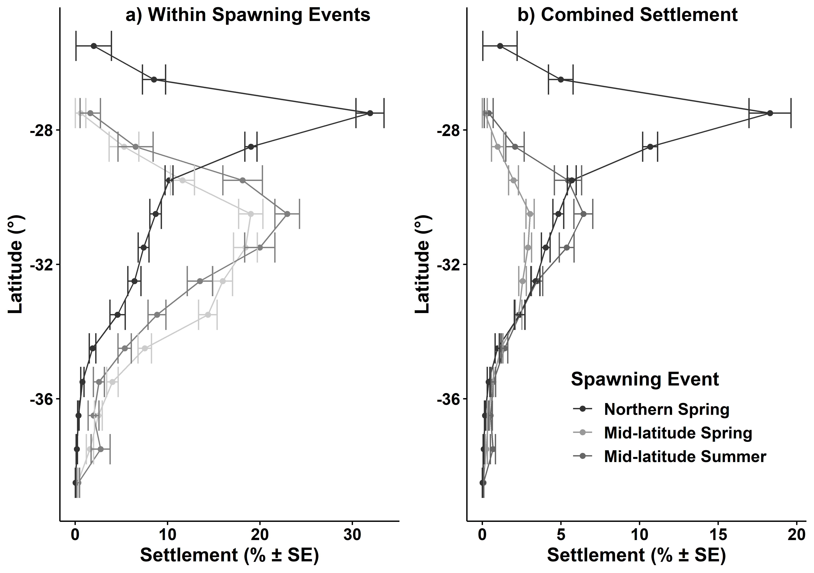

**Figure 4** Settlement contributions of different spawning periods for a) percentage of particles on the continental shelf within each spawning event and, b) As a percentage of all particles settled on the continental shelf (combined spawning events). All error bars show standard error.

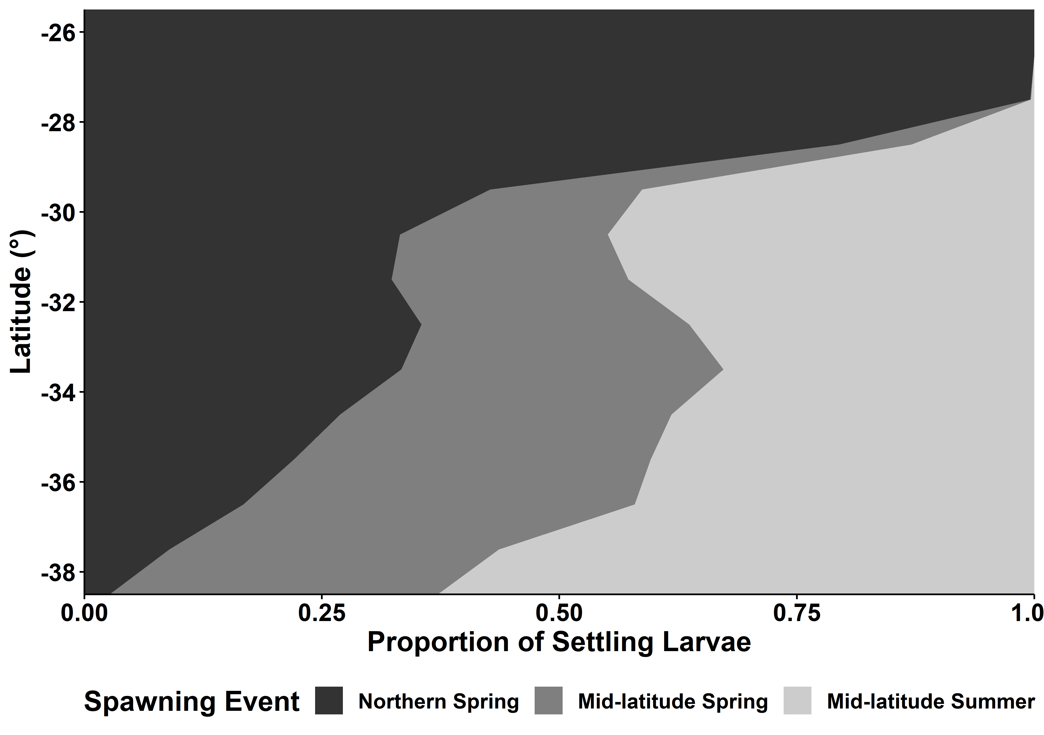

**Figure 5** Proportion of settled larvae (on the continental shelf) at 500 degree-days originating from each of the modelled spawning events, using 1° latitude settlement bins.

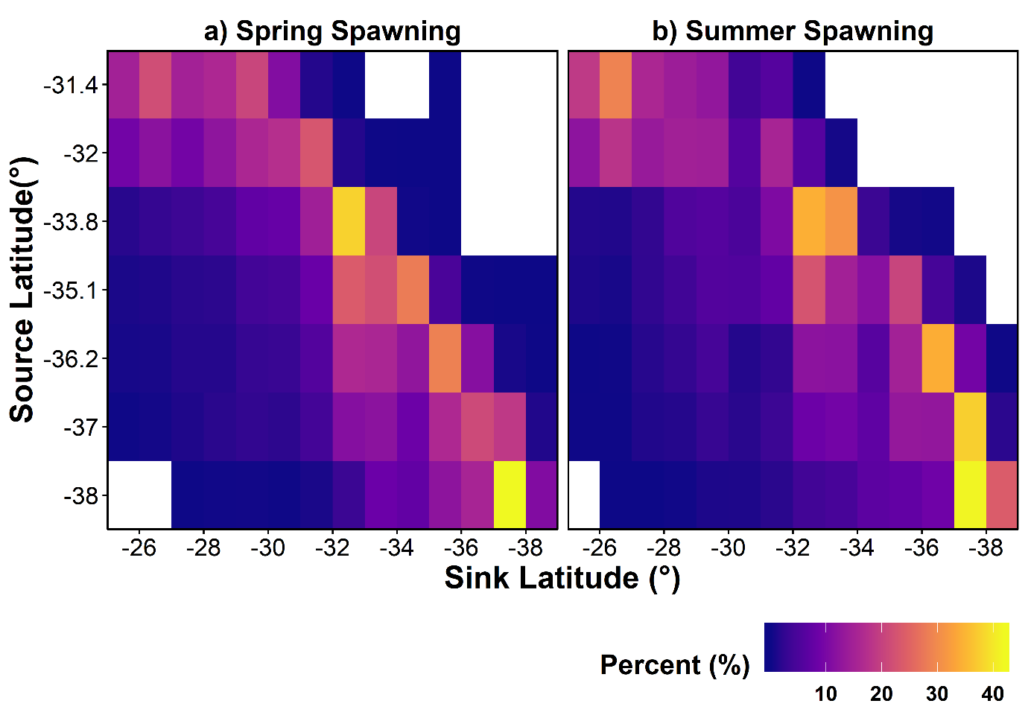

**Figure 6** Connectivity matrix for the backwards simulations for all particles which reached 500 DD on the continental shelf. The y-axis (source) represents the particle release latitudes detailed in Table 1 and Figure 1. The x-axis represents the 1° settlement latitude band.

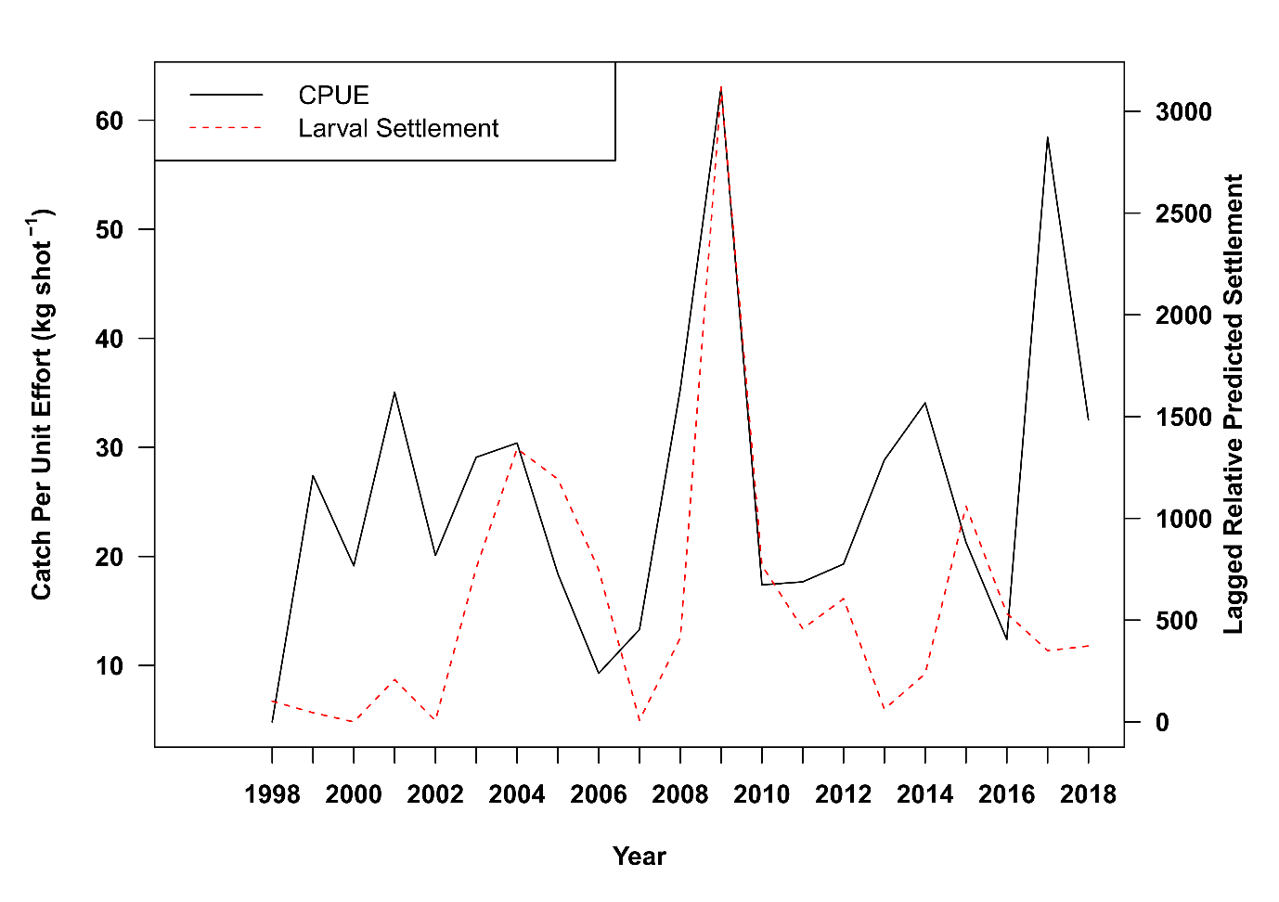

**Figure 7** Catch-per-unit-effort from the Gippsland Lakes in Victoria for *P. saltatrix* caught in seine nets (kg shot-1, black solid line) and the 2-year lagged relative predicted settlement of *P. saltatrix* larvaesouth of 37° S (red dashed line). The Pearson correlation coefficient of these two datasets is *r* = 0.463 (*P* = 0.034). Note the predicted larval settlement is on a log10 scale.

**References**

Andrello M, Mouillot D, Beuvier J, Albouy C, Thuiller W, Manel S (2013) Low Connectivity between Mediterranean Marine Protected Areas: A Biophysical Modeling Approach for the Dusky Grouper *Epinephelus marginatus*. PLOS ONE 8: e68564 doi 10.1371/journal.pone.0068564

Brodie S, Litherland L, Stewart J, Schilling HT, Pepperell JG, Suthers IM (2018) Citizen science records describe the distribution and migratory behaviour of a piscivorous predator, *Pomatomus saltatrix*. ICES J Mar Sci 75: 1573-1582 doi <https://doi.org/10.1093/icesjms/fsy057>

Cetina-Heredia P, Roughan M, Liggins G, Coleman MA, Jeffs A (2019) Mesoscale circulation determines broad spatio-temporal settlement patterns of lobster. PLOS ONE 14: e0211722 doi 10.1371/journal.pone.0211722

Cetina-Heredia P, Roughan M, van Sebille E, Coleman MA (2014) Long-term trends in the East Australian Current separation latitude and eddy driven transport. J Geophys Res (C Oceans) 119: 4351-4366 doi 10.1002/2014JC010071

Cetina-Heredia P, Roughan M, van Sebille E, Feng M, Coleman MA (2015) Strengthened currents override the effect of warming on lobster larval dispersal and survival. Global Change Biol 21: 4377-4386 doi 10.1111/gcb.13063

CNES (2015) SSALTO/DUACS User Handbook: (M)SLA and (M)ADT Near-Real Time and Delayed Time Products. AVISO Satellite Altimetry Data

Coleman MA, Feng M, Roughan M, Cetina-Heredia P, Connell SD (2013) Temperate shelf water dispersal by Australian boundary currents: Implications for population connectivity. Limnology and Oceanography: Fluids and Environments 3: 295-309 doi 10.1215/21573689-2409306

Coleman MA, Roughan M, Macdonald HS, Connell SD, Gillanders BM, Kelaher BP, Steinberg PD (2011) Variation in the strength of continental boundary currents determines continent-wide connectivity in kelp. J Ecol 99: 1026-1032 doi doi:10.1111/j.1365-2745.2011.01822.x

Condie SA, Mansbridge JV, Cahill ML (2011) Contrasting local retention and cross-shore transports of the East Australian Current and the Leeuwin Current and their relative influences on the life histories of small pelagic fishes. Deep Sea Research Part II: Topical Studies in Oceanography 58: 606-615 doi <https://doi.org/10.1016/j.dsr2.2010.06.003>

Cowen RK, Paris CB, Srinivasan A (2006) Scaling of Connectivity in Marine Populations. Science 311: 522 doi 10.1126/science.1122039

Cowen RK, Sponaugle S (2009) Larval Dispersal and Marine Population Connectivity. Annual Review of Marine Science 1: 443-466 doi 10.1146/annurev.marine.010908.163757

Davies KTA, Gentleman WC, DiBacco C, Johnson CL (2014) Semi-annual spawning in marine scallops strengthens larval recruitment and connectivity on Georges Bank: a model study. Mar Ecol Prog Ser 516: 209-227

Delandmeter P, van Sebille E (2019) The Parcels v2.0 Lagrangian framework: new field interpolation schemes. Geosci Model Dev Discuss 2019: 1-24 doi 10.5194/gmd-2018-339

Deuel DG, Clark JR, Mansueti AJ (1966) Description of embryonic and early larval stages of bluefish, *Pomatomus saltatrix*. Trans Am Fish Soc 95: 264-271

Everett JD, Baird ME, Oke PR, Suthers IM (2012) An avenue of eddies: Quantifying the biophysical properties of mesoscale eddies in the Tasman Sea. Geophys Res Lett 39: n/a-n/a doi 10.1029/2012GL053091

Everett JD, Sebille E, Taylor MD, Suthers IM, Setio C, Cetina-Heredia P, Smith JA (2017) Dispersal of Eastern King Prawn larvae in a western boundary current: New insights from particle tracking. Fish Oceanogr 26: 513-525 doi doi:10.1111/fog.12213

Fiksen Ø, Jørgensen C, Kristiansen T, Vikebø¸ F, Huse G (2007) Linking behavioural ecology and oceanography: larval behaviour determines growth, mortality and dispersal. Mar Ecol Prog Ser 347: 195-205

Fraser CI, Morrison AK, Hogg AM, Macaya EC, van Sebille E, Ryan PG, Padovan A, Jack C, Valdivia N, Waters JM (2018) Antarctica’s ecological isolation will be broken by storm-driven dispersal and warming. Nature Climate Change 8: 704-708 doi 10.1038/s41558-018-0209-7

Gallego A, North EW, Petitgas P (2007) Introduction: status and future of modelling physical-biological interactions during the early life of fishes. Mar Ecol Prog Ser 347: 121-126

Green BS, Fisher R (2004) Temperature influences swimming speed, growth and larval duration in coral reef fish larvae. J Exp Mar Biol Ecol 299: 115-132 doi <https://doi.org/10.1016/j.jembe.2003.09.001>

Hare JA, Cowen RK (1994) Ontogeny and otolith microstructure of bluefish *Pomatomus saltatrix* (Pisces: Pomatomidae). Mar Biol 118: 541-550 doi 10.1007/bf00347500

Hare JA, Cowen RK (1995) Effect of age, growth rate, and ontogeny on the otolith size – fish size relationship in bluefish, *Pomatomus saltatrix*, and the implications for back-calculation of size in fish early life history stages. Can J Fish Aquat Sci 52: 1909-1922 doi 10.1139/f95-783

Hare JA, Cowen RK (1996) Transport mechanisms of larval and pelagic juvenile bluefish (*Pomatomus saltatrix*) from South Atlantic Bight spawning grounds to Middle Atlantic Bight nursery habitats. Limnol Oceanogr 41: 1264-1280 doi 10.4319/lo.1996.41.6.1264

Hare JA, Cowen RK (1997) Size, growth, development, and survival of the planktonic larvae of *Pomatomus saltatrix* (Pisces: Pomatomidae). Ecology 78: 2415-2431 doi 10.1890/0012-9658(1997)078[2415:sgdaso]2.0.co;2

Hellweger FL, van Sebille E, Fredrick ND (2014) Biogeographic patterns in ocean microbes emerge in a neutral agent-based model. Science 345: 1346-1349 doi 10.1126/science.1254421

Hinrichsen H-H, Dickey-Collas M, Huret M, Peck MA, Vikebø FB (2011) Evaluating the suitability of coupled biophysical models for fishery management. ICES J Mar Sci 68: 1478-1487 doi 10.1093/icesjms/fsr056

Houde ED (1989a) Comparative growth, mortality, and energetics of marine fish larvae: temperature and implied latitudinal effects. Fish Bull 87: 471-495

Houde ED (1989b) Subtleties and episodes in the early life of fishes. J Fish Biol 35: 29-38 doi 10.1111/j.1095-8649.1989.tb03043.x

Hu D, Wu L, Cai W, Gupta AS, Ganachaud A, Qiu B, Gordon AL, Lin X, Chen Z, Hu S, Wang G, Wang Q, Sprintall J, Qu T, Kashino Y, Wang F, Kessler WS (2015) Pacific western boundary currents and their roles in climate. Nature 522: 299 doi 10.1038/nature14504

Juanes F, Hare JA, Miskiewicz AG (1996) Comparing early life history strategies of *Pomatomus saltatrix*: a global approach. Mar Freshwat Res 47: 365-379 doi <http://dx.doi.org/10.1071/MF9960365>

Kerry C, Powell B, Roughan M, Oke P (2016) Development and evaluation of a high-resolution reanalysis of the East Australian Current region using the Regional Ocean Modelling System (ROMS 3.4) and Incremental Strong-Constraint 4-Dimensional Variational (IS4D-Var) data assimilation. Geoscientific Model Development 9: 3779-3801 doi 10.5194/gmd-9-3779-2016

Kerry C, Roughan M (In Revision) Seasonal and Mesoscale Variability of the East Australian Current System. Journal of Geophysical Research

Lange M, van Sebille E (2017) Parcels v0.9: prototyping a Lagrangian ocean analysis framework for the petascale age. Geoscientific Model Development 10: 4175-4186 doi 10.5194/gmd-10-4175-2017

Leigh GM, O'Neill MF, Stewart J (2017) Stock assessment of the Australian east coast tailor (*Pomatomus saltatrix*) fishery. Queensland Department of Agriculture and Fisheries, Brisbane

Litherland L, Andrews J, Stewart J, Lewis P (2016) Tailor *Pomatomus saltatrix*. In: Stewardson C, Andrews J, Ashby C, Haddon M, Hartmann K, Hone P, Horvat P, Mayfield S, Roelofs A, Sainsbury K, Saunders T, Stewart J, Stobutzki I, Wise B (eds) Status of Australian fish stocks reports 2016. Fisheries Research and Development Corporation, Canberra

Maunder MN, Sibert JR, Fonteneau A, Hampton J, Kleiber P, Harley SJ (2006) Interpreting catch per unit effort data to assess the status of individual stocks and communities. ICES J Mar Sci 63: 1373-1385 doi 10.1016/j.icesjms.2006.05.008

McEvoy LA, McEvoy J (1992) Multiple spawning in several commercial fish species and its consequences for fisheries management, cultivation and experimentation. J Fish Biol 41: 125-136 doi doi:10.1111/j.1095-8649.1992.tb03874.x

Miranda T, Smith JA, Suthers IM, Mazumder D, Cruz DO, Schilling HT, Searle K, Vergés A (2019) Convictfish on the move: variation in growth and trophic niche space along a latitudinal gradient. ICES J Mar Sci doi 10.1093/icesjms/fsz098

Miskiewicz AG, Bruce BD, Dixon P (1996) Distribution of tailor (*Pomatomus saltatrix*) larvae along the coast of New South Wales, Australia. Mar Freshw Res 47: 331-336

Munroe DM, Haidvogel D, Caracappa JC, Klinck JM, Powell EN, Hofmann EE, Shank BV, Hart DR (2018) Modeling larval dispersal and connectivity for Atlantic sea scallop (*Placopecten magellanicus*) in the Middle Atlantic Bight. Fish Res 208: 7-15 doi <https://doi.org/10.1016/j.fishres.2018.06.020>

Neira FJ, Miskiewicz AG, Trnski T (1998) Larvae of temperate Australian fishes: laboratory guide for larval fish identification. UWA Publishing

Neuheimer AB, Taggart CT (2007) The growing degree-day and fish size-at-age: the overlooked metric. Can J Fish Aquat Sci 64: 375-385 doi 10.1139/f07-003

Nolasco R, Gomes I, Peteiro L, Albuquerque R, Luna T, Dubert J, Swearer SE, Queiroga H (2018) Independent estimates of marine population connectivity are more concordant when accounting for uncertainties in larval origins. Scientific Reports 8: 2641 doi 10.1038/s41598-018-19833-w

O'Connor MI, Bruno JF, Gaines SD, Halpern BS, Lester SE, Kinlan BP, Weiss JM (2007) Temperature control of larval dispersal and the implications for marine ecology, evolution, and conservation. Proceedings of the National Academy of Sciences 104: 1266-1271 doi 10.1073/pnas.0603422104

Oke PR, Roughan M, Cetina-Heredia P, Pilo GS, Ridgway KR, Rykova T, Archer MR, Coleman RC, Kerry CG, Rocha C, Schaeffer A, Vitarelli E (2019) Revisiting the circulation of the East Australian Current: Its path, separation, and eddy field. Prog Oceanogr 176: 102139 doi <https://doi.org/10.1016/j.pocean.2019.102139>

Oke PR, Sakov P, Cahill ML, Dunn JR, Fiedler R, Griffin DA, Mansbridge JV, Ridgway KR, Schiller A (2013) Towards a dynamically balanced eddy-resolving ocean reanalysis: BRAN3. Ocean Model Online 67: 52-70 doi <https://doi.org/10.1016/j.ocemod.2013.03.008>

Paris CB, Cowen RK, Claro R, Lindeman KC (2005) Larval transport pathways from Cuban snapper (Lutjanidae) spawning aggregations based on biophysical modeling. Mar Ecol Prog Ser 296: 93-106

Pineda J, Hare JA, Sponaugle SU (2007) Larval Transport and Dispersal in the Coastal Ocean and Consequences for Population Connectivity. Oceanography 20: 22-39

Pollock BR (1984) The tailor (*Pomatomus saltatrix*) fishery at Fraser Island and its relation to the life-history of the fish. Proc R Soc Queensl 95: 23 - 28

Putman Nathan F, Mansfield Katherine L (2015) Direct Evidence of Swimming Demonstrates Active Dispersal in the Sea Turtle “Lost Years”. Curr Biol 25: 1221-1227 doi <https://doi.org/10.1016/j.cub.2015.03.014>

Roemmich D, Johnson GC, Riser S, Davis R, Gilson J, Owens WB, Garzoli SL, Schmid C, Ignaszewski M (2009) The Argo Program: Observing the Global Ocean with Profiling Floats. Oceanography 22: 34-43

Rose GA, Kulka DW (1999) Hyperaggregation of fish and fisheries: how catch-per-unit-effort increased as the northern cod (*Gadus morhua*) declined. Can J Fish Aquat Sci 56: 118-127 doi 10.1139/f99-207

Roughan M, Macdonald HS, Baird ME, Glasby TM (2011) Modelling coastal connectivity in a Western Boundary Current: Seasonal and inter-annual variability. Deep Sea Research Part II: Topical Studies in Oceanography 58: 628-644 doi <http://dx.doi.org/10.1016/j.dsr2.2010.06.004>

Samsing F, Johnsen I, Dempster T, Oppedal F, Treml EA (2017) Network analysis reveals strong seasonality in the dispersal of a marine parasite and identifies areas for coordinated management. Landscape Ecol 32: 1953-1967 doi 10.1007/s10980-017-0557-0

Santos AMP, Nieblas AE, Verley P, Teles-Machado A, Bonhommeau S, Lett C, Garrido S, Peliz A (2018) Sardine (*Sardina pilchardus*) larval dispersal in the Iberian upwelling system, using coupled biophysical techniques. Prog Oceanogr 162: 83-97 doi <https://doi.org/10.1016/j.pocean.2018.02.011>

Schilling HT (2019) Ecology of tailor, *Pomatomus saltatrix*, in eastern Australia. PhD Thesis. School of Biological, Earth and Environmental Sciences, Sydney, Australia

Schilling HT, Reis-Santos P, Hughes JM, Smith JA, Everett JD, Stewart J, Gillanders BM, Suthers IM (2018) Evaluating estuarine nursery use and life history patterns of *Pomatomus saltatrix* in eastern Australia. Mar Ecol Prog Ser 598: 187-199 doi <https://doi.org/10.3354/meps12495>

Schilling HT, Smith JA, Stewart J, Everett JD, Hughes JM, Suthers IM (2019) Reduced exploitation is associated with an altered sex ratio and larger length at maturity in southwest Pacific (east Australian) *Pomatomus saltatrix*. Mar Environ Res 147: 72-79 doi <https://doi.org/10.1016/j.marenvres.2019.02.012>

Schunter C, Pascual M, Raventos N, Garriga J, Garza JC, Bartumeus F, Macpherson E (2019) A novel integrative approach elucidates fine-scale dispersal patchiness in marine populations. Scientific Reports 9: 10796 doi 10.1038/s41598-019-47200-w

Scutt Phillips J, Escalle L, Pilling G, Sen Gupta A, van Sebille E (2019) Regional connectivity and spatial densities of drifting fish aggregating devices, simulated from fishing events in the Western and Central Pacific Ocean. Environmental Research Communications 1: 055001 doi 10.1088/2515-7620/ab21e9

Siegel DA, Mitarai S, Costello CJ, Gaines SD, Kendall BE, Warner RR, Winters KB (2008) The stochastic nature of larval connectivity among nearshore marine populations. Proceedings of the National Academy of Sciences 105: 8974-8979 doi 10.1073/pnas.0802544105

Sloyan BM, Ridgway KR, Cowley R (2016) The East Australian Current and Property Transport at 27°S from 2012 to 2013. J Phys Oceanogr 46: 993-1008 doi 10.1175/jpo-d-15-0052.1

Souza JMACd, Powell B, Castillo-Trujillo AC, Flament P (2015) The Vorticity Balance of the Ocean Surface in Hawaii from a Regional Reanalysis. J Phys Oceanogr 45: 424-440 doi 10.1175/jpo-d-14-0074.1

Sun C, Feng M, Matear RJ, Chamberlain MA, Craig P, Ridgway KR, Schiller A (2012) Marine Downscaling of a Future Climate Scenario for Australian Boundary Currents. J Clim 25: 2947-2962 doi 10.1175/jcli-d-11-00159.1

Suthers IM, Young JW, Baird ME, Roughan M, Everett JD, Brassington GB, Byrne M, Condie SA, Hartog JR, Hassler CS, Hobday AJ, Holbrook NJ, Malcolm HA, Oke PR, Thompson PA, Ridgway K (2011) The strengthening East Australian Current, its eddies and biological effects — an introduction and overview. Deep Sea Research Part II: Topical Studies in Oceanography 58: 538-546 doi <http://dx.doi.org/10.1016/j.dsr2.2010.09.029>

Taylor DL, Able KW (2006) Cohort dynamics of summer-spawned bluefish as determined by length-frequency and otolith microstructure analyses. Trans Am Fish Soc 135: 955-969 doi 10.1577/T05-109.1

Treml EA, Roberts JJ, Chao Y, Halpin PN, Possingham HP, Riginos C (2012) Reproductive Output and Duration of the Pelagic Larval Stage Determine Seascape-Wide Connectivity of Marine Populations. Integr Comp Biol 52: 525-537 doi 10.1093/icb/ics101

Van Horn G, Mac Aodha O, Song Y, Cui Y, Sun C, Shepard A, Adam H, Perona P, Belongie S (2018) The inaturalist species classification and detection dataset Proceedings of the IEEE conference on computer vision and pattern recognition, pp 8769-8778

van Sebille E, Griffies SM, Abernathey R, Adams TP, Berloff P, Biastoch A, Blanke B, Chassignet EP, Cheng Y, Cotter CJ, Deleersnijder E, Döös K, Drake HF, Drijfhout S, Gary SF, Heemink AW, Kjellsson J, Koszalka IM, Lange M, Lique C, MacGilchrist GA, Marsh R, Mayorga Adame CG, McAdam R, Nencioli F, Paris CB, Piggott MD, Polton JA, Rühs S, Shah SHAM, Thomas MD, Wang J, Wolfram PJ, Zanna L, Zika JD (2018) Lagrangian ocean analysis: Fundamentals and practices. Ocean Model Online 121: 49-75 doi <https://doi.org/10.1016/j.ocemod.2017.11.008>

Vergés A, Steinberg PD, Hay ME, Poore AGB, Campbell AH, Ballesteros E, Heck KL, Booth DJ, Coleman MA, Feary DA, Figueira W, Langlois T, Marzinelli EM, Mizerek T, Mumby PJ, Nakamura Y, Roughan M, van Sebille E, Gupta AS, Smale DA, Tomas F, Wernberg T, Wilson SK (2014) The tropicalization of temperate marine ecosystems: climate-mediated changes in herbivory and community phase shifts. Proceedings of the Royal Society B: Biological Sciences 281 doi 10.1098/rspb.2014.0846

Victorian Fisheries Authority (2017) Review of key Victorian fish stocks — 2017, Melbourne, Victoria

Zeller BM, Pollock BR, Williams LE (1996) Aspects of the life history and management of tailor (*Pomatomus saltatrix*) in Queensland. Mar Freshwat Res 47: 323-329

Zilberman NV, Roemmich DH, Gille ST, Gilson J (2018) Estimating the Velocity and Transport of Western Boundary Current Systems: A Case Study of the East Australian Current near Brisbane. Journal of Atmospheric and Oceanic Technology 35: 1313-1329 doi 10.1175/jtech-d-17-0153.1

**Supplementary Material**

**Figure S1** Example of cumulative degree-days at 3 different constant water temperatures.

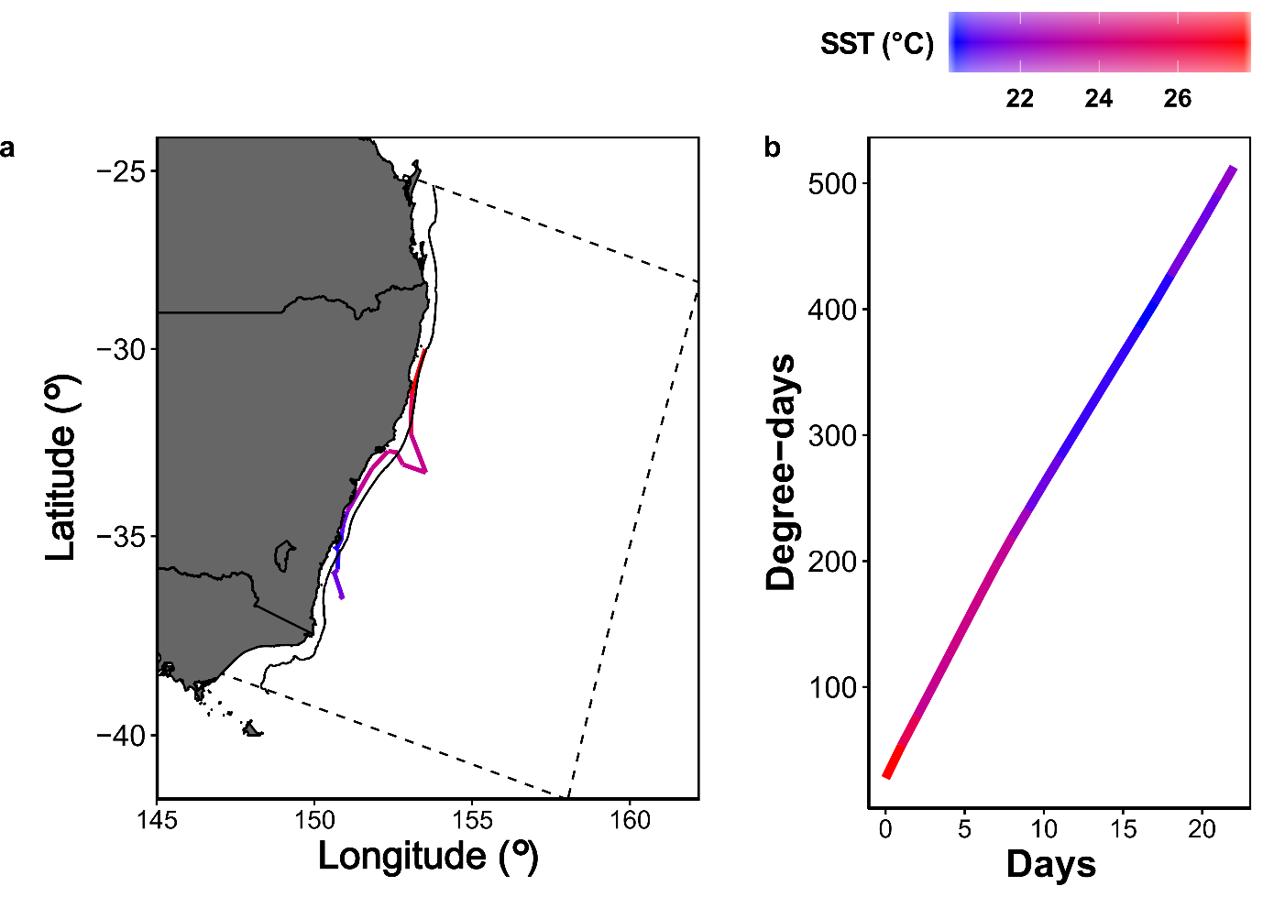

**Figure S2** Example of degree-days and path taken of a single particle which was released at -30°. Note the rate of increase in Degree-days slowly marginally as the water temperature experienced by the particle cools.

**Figure S3** Relationship between *Pomatomus saltatrix* length and degree-days, estimated from Deuel et al. (1966) and Hare and Cowen (1994).

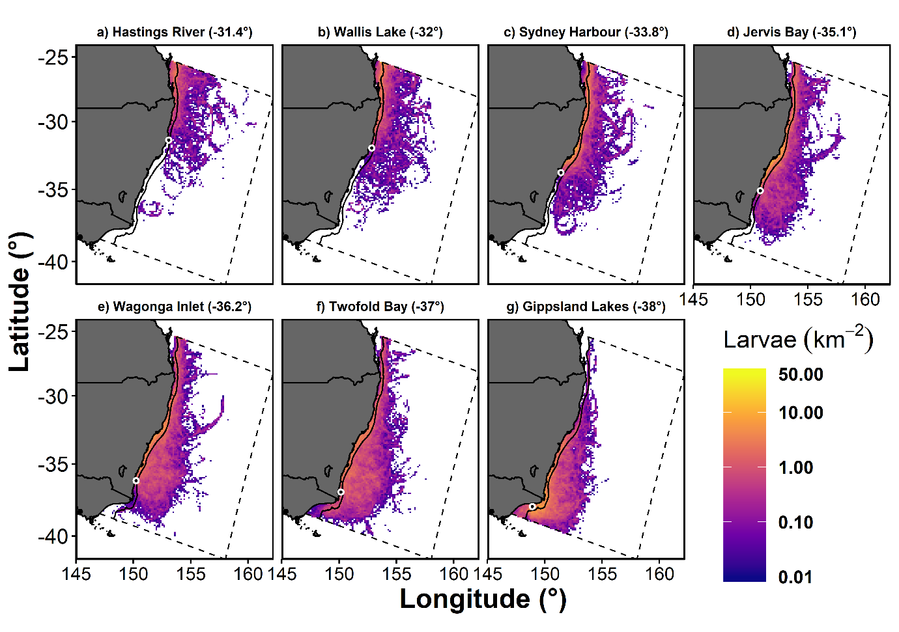

**Figure S4** Backwards tracking of larvae spawned during spring (August – December) showing the likely spawning locations (500 degree-days previously). Colour represents the relative density of larvae as the number of released particles was arbitrary. The dashed line box represents the boundary of the hydrodynamic model which provided the velocity fields (Kerry et al. 2016). The black dots with white outline represent the release locations for the particles in each simulation. Note the log10 scale on the colour scale.

**Figure S5** Backwards tracking of larvae spawned during summer (February & March) showing the likely spawning locations (500 degree-days previously). Colour represents the relative density of larvae as the number of released particles was arbitrary. The dashed line box represents the boundary of the hydrodynamic model which provided the velocity fields (Kerry et al. 2016). The black dots with white outline represent the release locations for the particles in each simulation. Note the log10 scale on the colour scale.

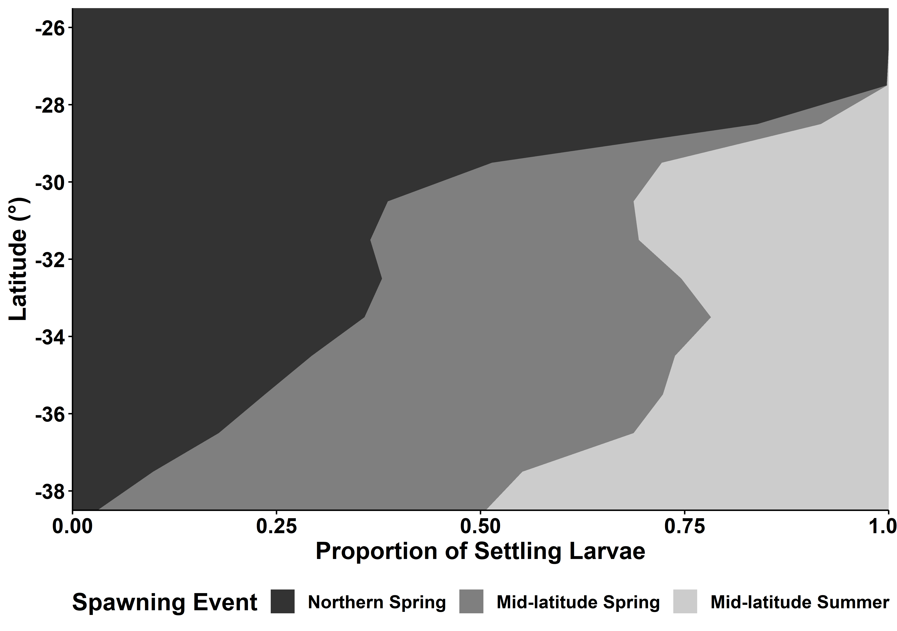

**Figure S6** Proportion of settled larvae (on the continental shelf) at 500 degree-days originating from each of the modelled spawning events with no mortality applied, using 1° latitude bins.

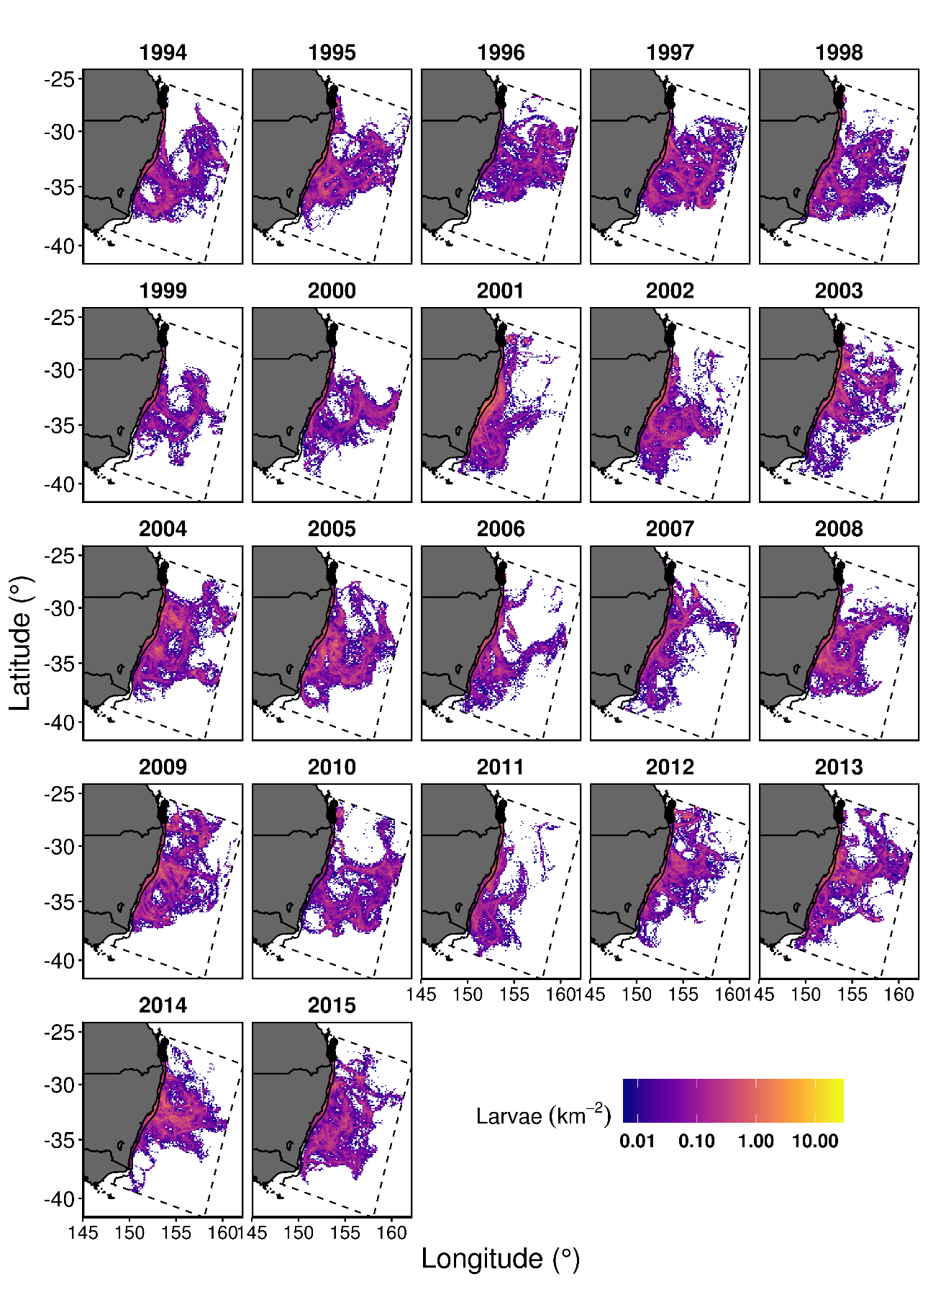

**Figure S7** Annual variation in relative density of larvae at settlement time (500 degree-days) for the northern spring spawning event. The black circles show the release location of the particles for each spawning event. The continental shelf (200 m depth) is shown as a solid black line within the model boundaries. The density colour scale is consistent between subplots but note the non-linear colour scale.

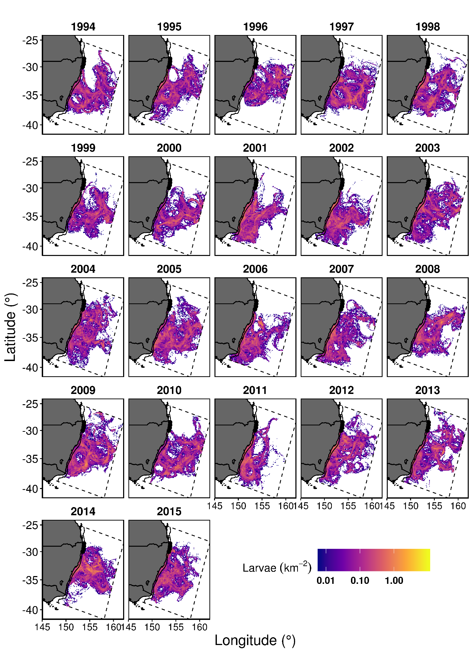

**Figure S8** Annual variation in relative density of larvae at settlement time (500 degree-days) for the mid-latitude spring spawning event. The black circles show the release location of the particles for each spawning event. The continental shelf (200 m depth) is shown as a solid black line within the model boundaries. The density colour scale is consistent between subplots but note the non-linear colour scale.

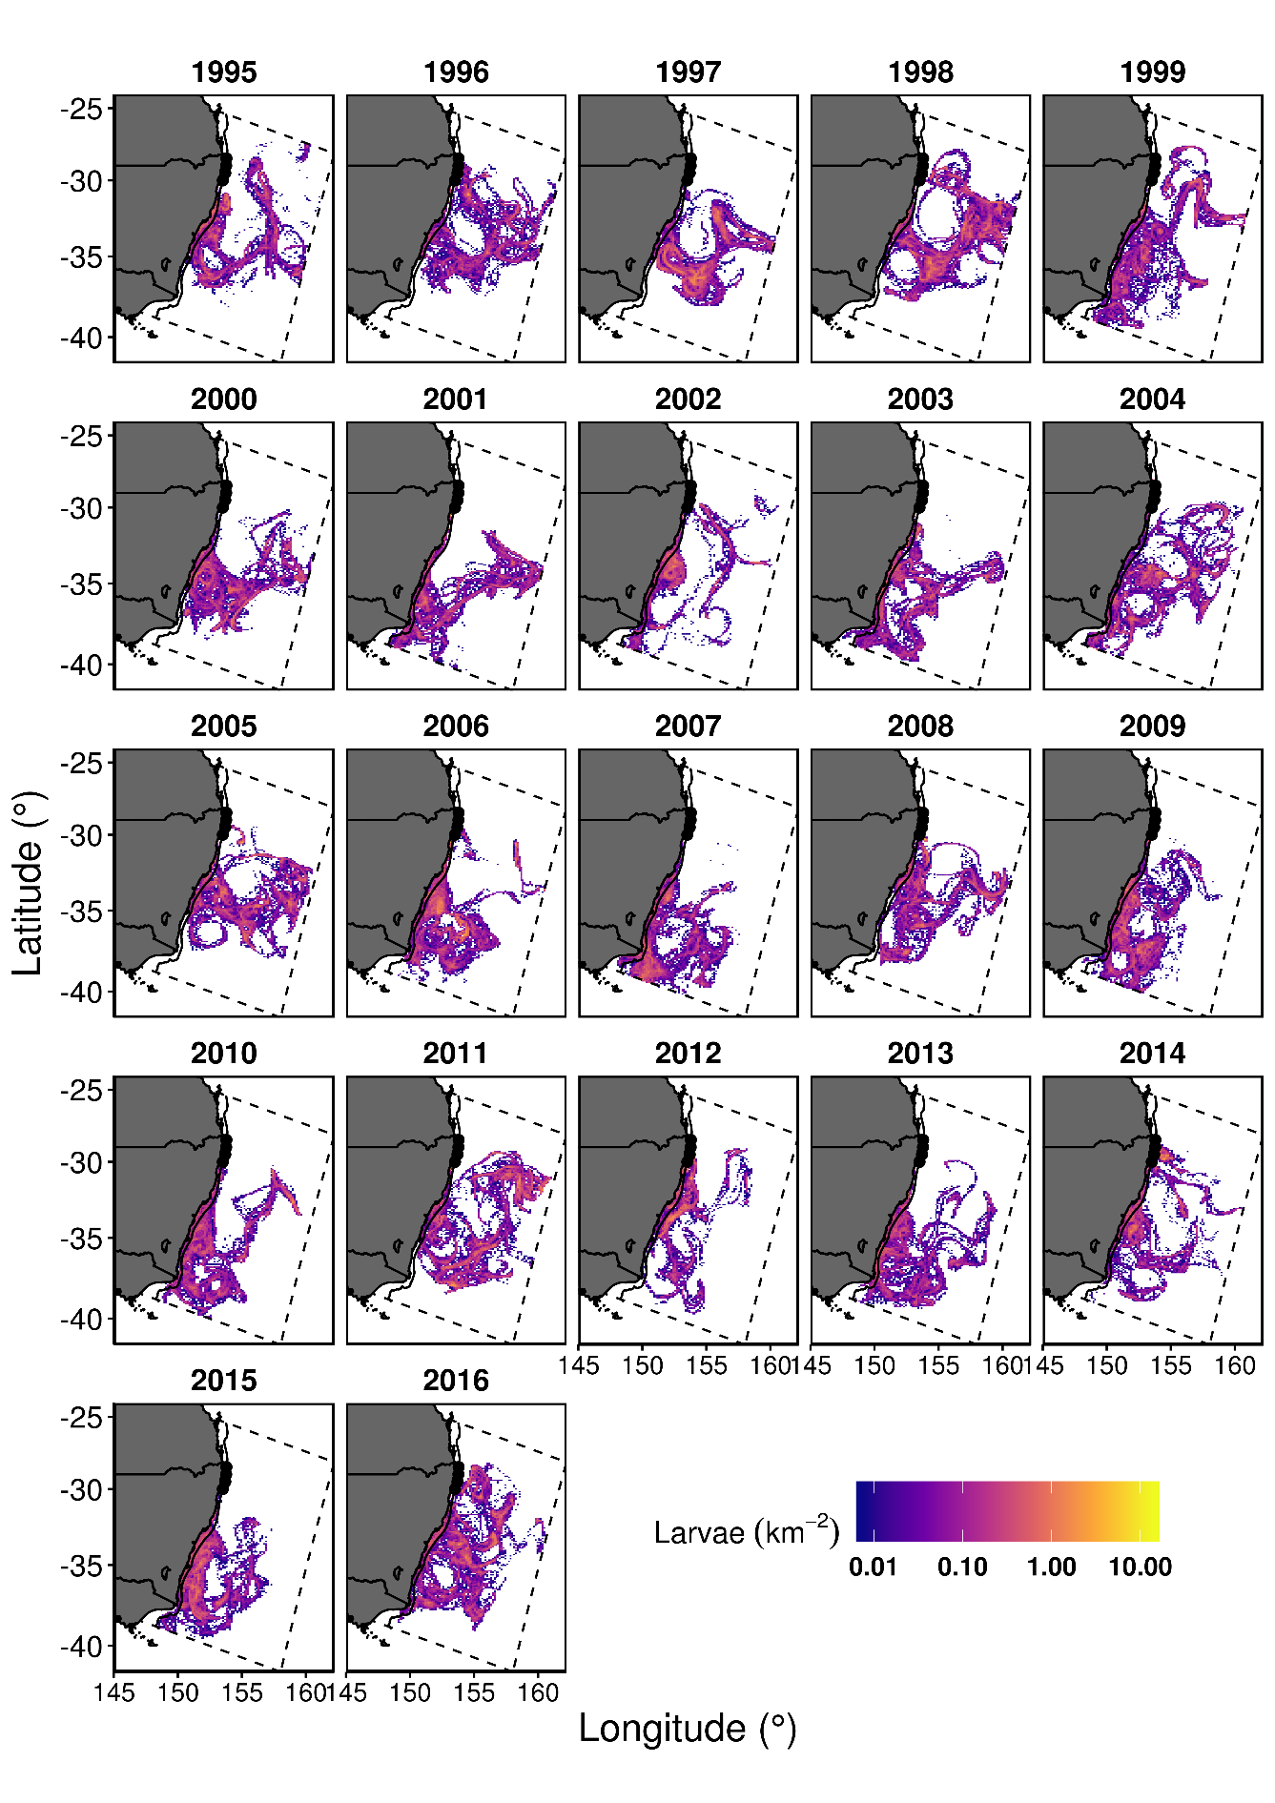

**Figure S9** Annual variation in relative density of larvae at settlement time (500 degree-days) for the mid-latitude summer spawning event. The black circles show the release location of the particles for each spawning event. The continental shelf (200 m depth) is shown as a solid black line within the model boundaries. The density colour scale is consistent between subplots but note the non-linear colour scale.